RISK ASSESSMENT  Young People  On Site  For Activities  NOT Residential | Assessed by: | Date: | Title of Assessment
 | J M Illingworth | 14/07/2020 | COVID-19: Young People undertaking activities on Wike Campsite. | RA-CV-03
 |  |  | Consultation with the Workforce & Publishing of this Assessment
 | Date to be reviewed | Gov. Updates/  Monthly | The final results of this risk assessment will be shared as appropriate.
 | Date of last review | 03/08/2020
 | Reviewed by

HAZARD | WHO AFFECTED | EXISTING RISK CONTROLS | FURTHER RISK CONTROLS NECESSARY
Social Distancing on site  Failure to maintain compliance with social distancing during completion of the task resulting in increased risk of transmission. | Everyone on site | - The key objective is to maintain social distancing on site wherever possible.  - Everyone should remain at least two metres apart whilst on site wherever reasonably practical.  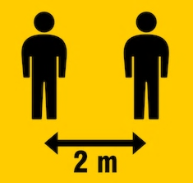  - Everyone will follow all site social distancing rules. | - Place signs showing area where groups may walk.  - Place barrier tape and/or rope to block off no go areas  - Use "No Entry" signs and other signage as appropriate.  - Define permitted routes.  - Limit the number of people on site.  - Groups clearly separated. 25m apart
Coming to Site and Leaving Site  Failure to maintain compliance with social distancing during arrival and departure resulting in increased risk of transmission. | Everyone on site | - Everyone must follow current Government guidelines when travelling to and from the campsite.  - Everyone will be required to wash/sanitise their hands whenever entering or leaving the site.  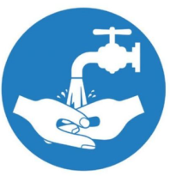  - Only the group sizes specified by HQ plus an additional leader to help staff the toilet block. A minimum of two members of the District Team / site staff will be present on site.  - Any equipment brought to site must be sanitised before use and again at the end of the session.  - Everyone to maintain social distancing when accessing and leaving site – keeping 2m apart.
Moving around the Site  Failure to maintain compliance with social distancing during completion of the task resulting in increased risk of transmission. | Everyone on site | - Signage placed at ground levels/other objects to give guidance 2 metre social distancing will be adhered to.  - Everyone required to stick to own designated areas and not encroach into areas where they are not allowed. | - Managers to continue to monitor the effectiveness of existing risk controls and amend as required.
Toilet Areas:  Failure to maintain compliance with social distancing and surface transmission prevention in the common areas resulting in increased risk of transmission. | Everyone on site | - Wash or sanitise hands before and after using the facilities.  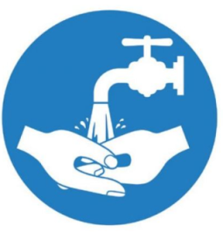  - Hand wash after every use of the toilet.  - One person at once in a toilet, one toilet allocated to each group.  - Avoid contact with frequently touched surfaces where possible e.g.:  - Opening doors with feet/elbows or paper towels.  - Using tissue to switch off taps or contact surfaces. | - Managers to liaise ensure that the welfare arrangements are being suitably managed (enhanced cleaning, signs, soap provision) prior to attending site.  - Provide hand sanitiser (minimum 60% alcohol based) to augment hand washing.
Common Areas:  Car Parks  Failure to maintain compliance with social distancing in the car parks resulting in increased risk of transmission. | Everyone on site | - Everyone is required to maintain 2 metre separation in car park areas.  - Parking/drop off area. A clear time gap of at least 30 minutes between each group using the car park. | - Managers to continue to monitor the effectiveness of existing risk controls and amend as required.
Accidents, Security and Other Incidents  Failure to manage appropriately/  attempting to maintain social distancing during accidents and incidents. | Everyone on site | - Ambulance to be used in an emergency.  - Each group visiting will bring sufficient First Aid provision for their intended activities.  - First aiders at site to:  - Make sure they wash hands or use an alcohol gel, before and after treating a casualty.  - Wear a face mask and ensure they do not cough or sneeze over a casualty during treatment.  - Not lose sight of other cross contamination that could occur that is not related to COVID-19.  - Wear gloves or cover hands when dealing with open wounds.  - Cover cuts and grazes on their hands with waterproof dressing.  - Dispose of all waste safely.  - Do not touch a wound with a bare hand.  - Do not touch any part of a dressing that will come in contact with a wound.  - In an emergency, for example a fire or accident Everyone do not have to stay 2m apart if it would be unsafe. | - Emergency plans including contact details should be kept up to date.  - Consideration must also be given to potential delays in emergency services response, due to the current pressure on resources.  - If anyone develops symptoms of COVID-19 or is observed to be displaying symptoms they will be removed from the activity area and:  - Return home if safe to do so  - If not able, driven home by another with additional controls:  - Keep windows open  - Keep distance (driver in front and passenger in rear)  - Clean down vehicle following transport.  - Contact emergency services if significant.  - Include the outside of first aid kits on regular sanitisation procedures.
Cleaning the Facilities  - General Cleaning  - Handwashing  - Sanitation Facilities  - Toilets  Failure to reduce transmission through contact with contaminated surfaces by not keeping the workplace clean. | Everyone on site | - Standard cleaning products will be used as part of the enhanced cleaning programme.  - Everyone is required to maintain their allocated area in a clean and hygienic manner.  - Everyone will dispose of rubbish in appropriate manner. This Should removed from site on the conclusion of the activity. | - Managers to introduce an enhanced cleaning and sanitisation programme for appropriate parts of the site after each activity session to include key touch points & areas such as:  - Door handles  - Door push plates  - Light switches  - First aid kit containers  - W/C handles  - Taps  - Soap dispensers  - W/Cs  - Site staff will be provided with personal sanitiser  - Provide site staff with their own pack of sanitising wipes.
General Hygiene:  - Handwashing  - Sanitation Facilities  - Toilets  Failure to reduce transmission through contact with contaminated surfaces or direct exposure to airborne particulates by not enforcing good hygiene practices. | Everyone on site | - Regular hand washing breaks to be taken throughout the activity where required.  - Avoid Greetings: Avoid physical greetings (hand shaking etc).  - Avoid Skin Contact: Avoid touching eyes, nose and mouth.  - Practice respiratory hygiene: This means covering your mouth and nose with your bent elbow or tissue when you cough or sneeze. Then dispose of the used tissue immediately.  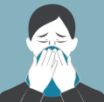  - All Everyone must use hand sanitiser when entering and leaving the site.  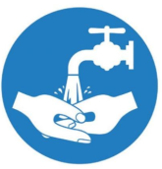  - Wash or sanitise hands before and after using the site W/C facilities.  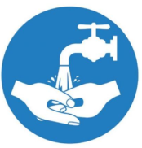  - Avoid contact with frequently touched surfaces where possible e.g.:  - Opening doors with feet/elbows.  - Using tissue to switch off taps or contact surfaces.  - No reusable towels/nail brushes/face cloths permitted on the site.  - Everyone instructed in good personal hygiene practice by the use of posters.  - Any surfaces recently contacted by affected individuals to be isolated and thoroughly cleaned in line with current guidance at: https://www.gov.uk/government/publications/covid-19-decontamination-in-non-healthcare-settings/covid-19-decontamination-in-non-healthcare-settings  - If a anyone on site has helped someone who was taken unwell with a new, continuous cough or a high temperature, they do not need to go home unless they develop symptoms themselves. They should wash their hands thoroughly for 20 seconds after any contact with someone who is unwell with symptoms consistent with coronavirus infection.  - If waste is considered to be contaminated with Covid-19 virus remove and place into a plastic bag any wipes, disposable gloves and overalls used, whilst trying not to cross-contaminate onto existing clothes or persons.  - Waste should be double bagged and sealed.

For further advice and reference please see:
- www.scouts.org.uk/coronavirus

Key COVID-19 Symptoms & Controls:

Note: DO NOT ATTEND SITE – a) if you are unwell/displaying symptoms b) if someone in your household is self-isolating
Symptoms: | Hand Washing:

- Before leaving site wash your hands with soap and water for at least 20 seconds. Use an alcohol-based hand sanitiser that contains at least 60% alcohol if soap and water are not available.
Document Accepted By (Name) |  | Sign |  | Date
Further Risk Controls Implemented By (Name) |  | Sign |  | Date

The contents of this risk assessment should be shared with everyone as appropriate to its contents.

